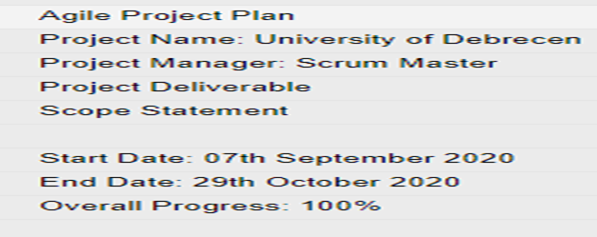
Figure 1 : Agile Project Plan

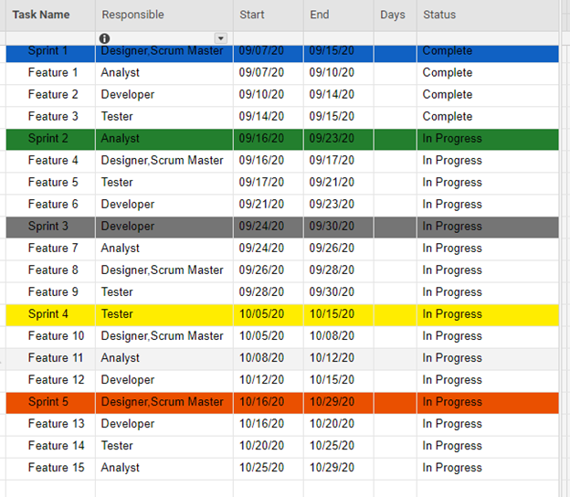
Figure 2 : Sprint Planning
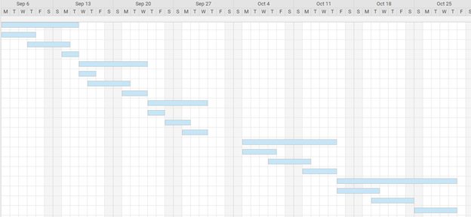
Figure 3 : Sprint Planning Graph

